**Bridging the Gap: Uncovering Behavioral Barriers to Preventive Care Engagement in LPPO Plans**



Humana-Mays HealthCare Analytics

2024 Case Competition

**Table of Contents**

**Table of Contents………………………………………………………………………………...2**

**1. Executive Summary…………………………………………………………………………...3**

1.1 Study Proposal………………………………………………………………………….

1.2 Modeling and Analysis…………………………………………………………………

1.3 Results and Recommendations…………………………………………………………

**2. Case Background……………………………………………………………………………….**

2.1 Business Problem……………………………………………………………………….

2.2 Key Performance Indicators……………………………………………………………

**3. Data Preparation………………………………………………………………………………..**

3.1 Data Description………………………………………………………………………..

3.2 Exploratory Data Analysis……………………………………………………………...

3.3 Data Preprocessing……………………………………………………………………...

**4. Statistical Analysis and Modeling……………………………………………………………..**

4.1 Model Selection………………………………………………………………………...

4.2 Hyperparameter Optimization………………………………………………………….

4.3 Model Results…………………………………………………………………………..

4.4 Model Interpretation……………………………………………………………………

4.5 Clustering Analysis……………………………………………………………………..

**5. Business Implications and Recommendations………………………………………………..**

**6. Conclusion………………………………………………………………………………………**

**7. References………………………………………………………………………………………**

# 1. Executive Summary

## 1.1 Study Proposal

Humana's Local Preferred Provider Organization (LPPO) plan has seen significant growth in membership. However, a key challenge arises with the high number of members who do not engage in preventive visits with their Primary Care Physician (PCP). This lack of engagement leads to missed opportunities for health screenings and medication monitoring, potentially leading to worse health outcomes for members and reduced Stars performance for Humana.

The objective of our study is to develop a predictive model that can identify members who are at risk of not engaging in a preventive visit within the calendar year. Using data from Humana's LPPO members, we aim to derive insights into engagement behavior and propose actionable strategies to increase member engagement.

## 1.2 Modeling and Analysis

Our analysis focused on identifying the characteristics and behaviors of members that lead to disengagement from preventive PCP visits. Using data from Humana's LPPO membership, we built a predictive model with key performance indicators (KPIs) aligned with business goals. The dataset includes information on demographics, claims, plan details, and interactions with healthcare providers.

For model selection, we started with a train-test split (80:20) and used tree-based models to account for non-linearity and correlated features. The following models were considered:

1. eXtreme Gradient Boosting: XGBoost
2. Light Gradient Boosting Machine: LightGBM
3. Category Boosting: CatBoost
4. Blending 3 Models (XGBoost, LightGBM, CatBoost)
5. Stacking 3 Models (XGBoost, LightGBM, CatBoost) - Logistic Regression
6. Stacking 3 Models (XGBoost, LightGBM, CatBoost) - Random Forest
7. Deep Neural Networks (DNN)

Cross-validation was applied to ensure generalization, and hyperparameter optimization was performed using Bayesian optimization. The key parameters optimized included:

1. Number of individual tree models
2. Criterion for splitting the nodes
3. Maximum depth for each tree
4. Minimum samples needed at leaf nodes

The model’s performance was evaluated using metrics like AUC-ROC, Precision-Recall curves, and confusion matrix. Feature importance analysis, SHAP value graphs, and clustering were used to interpret the model.

## 1.3 Results and Recommendations

Our analysis identified four distinct clusters within Humana’s LPPO members, revealing key challenges and guiding targeted strategies to improve engagement and reduce costs:

Results:

1. Lower healthcare needs but high reliance on ER (ER-to-PCP ratio: 120.61).
2. High Specialist-to-PCP ratio of 652.66, indicating over-reliance on specialists.
3. High severity (Charlson Comorbidity Index score: 7.2) and neglect of preventive care.
4. Psychological barriers and social challenges limiting preventive care engagement.

Recommendations:

1. Educate members on using primary, emergency, and specialist care appropriately.
2. Tailor outreach for veterans and high-risk members, emphasizing preventive care and early intervention.
3. Improve communication between PCPs and specialists, and schedule follow-up visits to reduce emergency visits.
4. Offer rewards like wellness credits and discounts for engaging in preventive services.
5. Enhance virtual care options and provide transportation support for high-risk members.

By adopting these strategies, Humana can promote better health behaviors, strengthen care coordination, and achieve substantial cost savings, ultimately benefiting both members and the healthcare system.

# 2. Case Background

Humana’s Local Preferred Provider Organization (LPPO) plan has experienced significant growth in membership over recent years. However, a critical challenge arises as many members fail to engage with their Primary Care Physicians (PCP) for preventive visits. This lack of preventive care engagement reduces the opportunity for early detection of health issues and ongoing monitoring, which could lead to worse health outcomes for members and a decline in Humana's Stars ratings. Preventive visits play a key role in the healthcare ecosystem by enabling early detection of chronic diseases, reducing overall healthcare costs, and improving patient outcomes.

The growing disengagement in preventive care represents a major challenge for Humana, both in terms of patient health outcomes and business performance. When members miss these essential touchpoints with their healthcare providers, it increases the risk of complications from untreated conditions and raises healthcare costs through more severe interventions later in the treatment process. The need for early intervention and continuous monitoring is particularly important given the rise in chronic conditions and the increasing costs associated with managing them.

## 2.1 Business Problem

Humana's LPPO plan faces a persistent issue with members not participating in preventive visits with their PCPs. This lack of engagement significantly impacts the ability of healthcare providers to perform necessary health screenings, monitor chronic conditions, and provide personalized care. From a business perspective, this disengagement not only risks poorer health outcomes for members but also jeopardizes Humana's Stars performance ratings. These ratings are directly tied to revenue, and lower engagement results in financial loss for Humana.

To address this challenge, our analysis seeks to:

1. Identify members most likely to skip their preventive PCP visits by developing a predictive model.
2. Provide actionable insights to help Humana implement outreach strategies that improve engagement rates and, consequently, improve both member health outcomes and business performance.

## 2.2 Key Performance Indicators

**2.2.1 Confusion Matrix**

The confusion matrix provides a comprehensive view of how our classification model’s predictions align with actual member behavior. It breaks down the model's predictions into four categories: True Positives (members correctly predicted to skip preventive visits), True Negatives (members correctly predicted to attend their preventive visits), False Positives (members predicted to skip their visit but who actually attended), and False Negatives (members predicted to attend but who skipped their visit).

This breakdown allows Humana to see where the model excels and where improvements can be made, particularly in minimizing False Negatives, which represent members predicted to attend their preventive visit but who actually do not. By reducing these False Negatives, Humana can take preemptive action, reaching out to members at risk of skipping preventive visits and ensuring their engagement.

**2.2.2 AUC-ROC Curve**

The AUC-ROC (Area Under the Receiver Operating Characteristic) curve provides a visualization of how well our classification model differentiates between members who are likely to engage in preventive visits and those who are not. The True Positive Rate (sensitivity) is plotted against the False Positive Rate at various thresholds, offering insight into the model's ability to predict member engagement.

A higher AUC represents a stronger ability of the model to distinguish between engaged and disengaged members. In this study, we aim to achieve a high AUC to ensure accurate prediction of members who are likely to skip preventive visits, allowing for effective targeted interventions.

**2.2.3 AUC for Precision-Recall Curve**

Considering the imbalance in the dataset—where most members engage with their PCP and only a smaller fraction do not—the Precision-Recall (PR) curve is crucial. The curve plots Precision (the proportion of predicted non-engaged members that are actually non-engaged) against Recall (the proportion of actual non-engaged members correctly identified by the model). This curve helps us assess the model’s ability to correctly identify non-engaged members, especially important in cases where missing preventive care can have significant health and cost implications.

The area under the PR curve gives us a singular value summarizing the model’s effectiveness in managing this minority class. The goal is to have a PR AUC value close to 1, optimizing for the balance between precision and recall.

**2.2.4 Feature Importance**

Feature importance helps us understand which variables contribute the most to predicting preventive visit engagement. By analyzing the model's feature importance rankings, we can identify key drivers behind members' decisions to attend or skip preventive visits. In our model, the top features include the following along with their benefits:

1. Demographic information (such as age, state, and region): Highlighting differences in engagement patterns across various population segments.
2. Medical history (such as past visits, chronic disease diagnoses, and medication adherence): Providing insight into the correlation between member health conditions and preventive care engagement.
3. Expenditure patterns (including healthcare costs and insurance coverage details): Showing how financial factors might influence a member's likelihood to engage in preventive care.

By understanding these key factors, Humana can prioritize outreach efforts and resource allocation to focus on members most at risk of disengagement. This approach ensures that engagement strategies are data-driven, improving member health outcomes and optimizing business performance.

# 3. Data Preparation

## 3.1 Data Description

We received two sets of files from Humana this year - the training datasets used for exploration and training the models and the holdout file used for predictions.

Both the training and holdout datasets consisted of 14 tables with different aspects of the patients, ranging from demographic information to their medical history. We have information for over 1.5 million patients. A brief summary of the datasets is as below:

|  |  |  |
| --- | --- | --- |
| **Dataset** | **#Rows** | **#Columns** |
| Target Members | 1,527,904 | 5 |
| Additional Features | 1,527,904 | 12 |
| Marketing Control Point | 1,527,904 | 66 |
| Cost & Utilization | 1,527,904 | 36 |
| Demographics | 1,527,904 | 7 |
| Pharmacy Utilization | 1,527,904 | 17 |
| Sales Channel | 1,527,904 | 2 |
| Social Determinants of Health | 1,527,904 | 78 |
| Web Activity | 1,527,904 | 15 |
| Member Data | 1,527,904 | 7 |
| Quality Data | 33,572,241 | 8 |
| Member Details | 1,527,904 | 13 |
| Member Claim | 19,456,796 | 27 |
| Member Condition | 4,009,342 | 7 |

The ‘Target Members’ dataset included our target variable for prediction: ‘preventive_visit_gap_ind’. All the datasets were merged using the unique identifier ‘id’ which corresponds to the patient ID.

## 3.2 Data Preprocessing

In the initial phase of data cleaning, we dropped the rows where all columns had null values. We assume this was due to no information available for that particular patient ID. The same ids were dropped from all the datasets, ensuring cohesiveness. We noticed infinity values in some of the percentages, which was replaced by 0.

We then looked at the percentages of null values and dropped columns with more than 2% of null values, since there was no logical way to impute values in those columns. In cases where null values were less than 2%, we imputed values using 0 or median (wherever applicable).

We looked at few of the columns and decided to aggregate a few columns and create new ones:

|  |  |
| --- | --- |
| **New Features** | **Description** |
| 'cnt_cp_interact' | Includes ’cnt_cp_emails_’, 'cnt_cp_print_', 'cnt_cp_vat_', 'cnt_cp_webstatement_' grouped from 0 to 2, 3 to 5, 6 to 8, 9 to 11. |
| 'login_count_*' | Includes columns starting with 'login_count_’ grouped from 0 to 2, 3 to 5, 6 to 8, 9 to 11. |
| 'nonp_oonw_clm_ct' | Equal to ('nonpar_clm_ct_pmpm' + 'oontwk_clm_ct_pmpm') |
| 'nonp_oonw_cost' | Equal to ('nonpar_allowed_pmpm_cost' + 'oontwk_allowed_pmpm_cost') |
| 'nonp_oonw_ds_clm' | Equal to ('nonpar_ds_clm' + 'oontwk_ds_clm') |
| 'nonp_oonw_paid_insured_pct' | Equal to ('nonpar_coins_pmpm_cost' + 'nonpar_copay_pmpm_cost' + 'nonpar_deduct_pmpm_cost' + 'oontwk_coins_pmpm_cost' + 'oontwk_copay_pmpm_cost' + 'oontwk_deduct_pmpm_cost') divided by ('nonpar_allowed_pmpm_cost' + 'oontwk_allowed_pmpm_cost') |
| 'nonp_oonw_paid_insurer_pct' | Equal to ('nonpar_net_paid_pmpm_cost' + 'nonpar_cob_paid_pmpm_cost' + 'oontwk_net_paid_pmpm_cost' + 'oontwk_cob_paid_pmpm_cost') divided by ('nonpar_allowed_pmpm_cost' + 'oontwk_allowed_pmpm_cost') |
| 'total_cost' | Equal to 'total_allowed_pmpm_cost' |
| 'total_paid_insurer_pct' | Equal to ('total_net_paid_pmpm_cost' + 'total_cob_paid_pmpm_cost') divided by 'total_cost' |
| 'total_paid_insured_pct' | Equal to ('total_coins_pmpm_cost' + 'total_copay_pmpm_cost' + 'total_deduct_pmpm_cost') divided by 'total_cost' |
| 'total_ip_acute_days' | Equal to ('total_ip_acute_admit_days_pmpm' + 'total_ip_ltach_admit_days_pmpm' + 'total_ip_maternity_admit_days_pmpm') |
| 'total_ip_nonacute_days' | Equal to ('total_ip_mhsa_admit_days_pmpm' + 'total_ip_rehab_admit_days_pmpm' + 'total_ip_snf_admit_days_pmpm') |
| 'combined_uninsured' | Mean of ('rwjf_uninsured_adults_pct', 'rwjf_uninsured_child_pct', 'rwjf_uninsured_pct') |
| 'unhealthy_behavior_score' | Mean of ('rwjf_food_insecurity_pct', 'rwjf_insufficient_sleep_pct', 'rwjf_limit_hlthy_food_pct', 'rwjf_inactivity_pct', 'rwjf_alcoholic_pct', 'rwjf_adult_obesity_pct', 'rwjf_adult_smoking_pct') |
| 'cond_category' | Mapped the various diseases in 'cond_desc' into different categories |

We created dummies for various categorical variables to assist with the model. Lastly, we explored all the columns that were irrelevant to the target variable and dropped them.

The final dataset used for modeling included 302 features for 1,526,758 patients.

## 3.3 Exploratory Data Analysis

**3.3.1 Preventive Visit Gap Index by State**

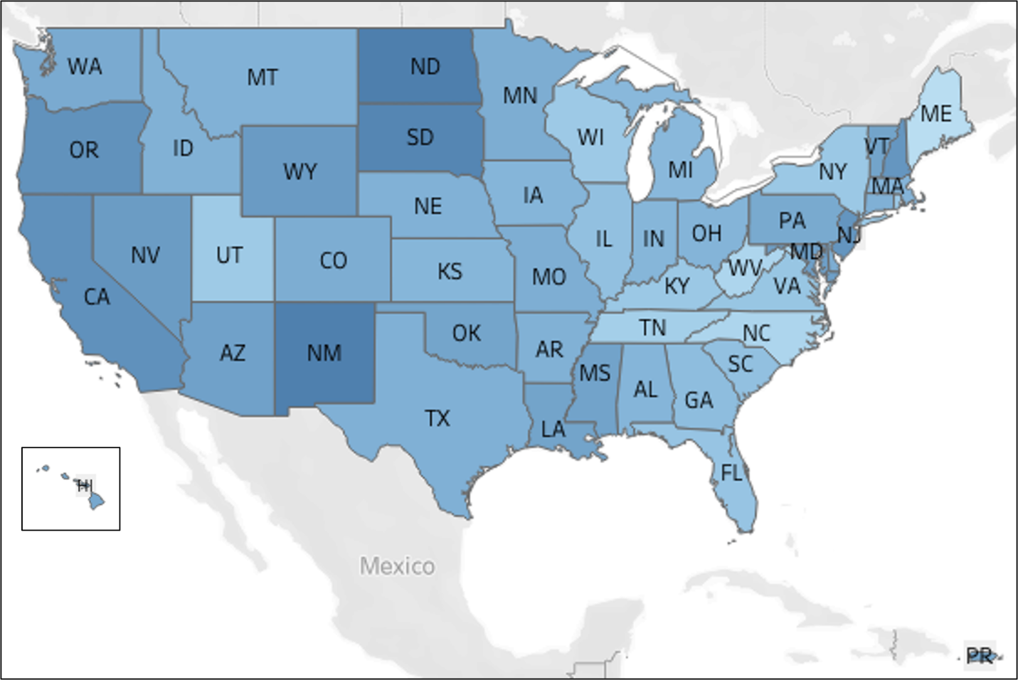

*Fig 1: Preventive Visit Gap Index by State*

The five states with the highest PREVENTIVE_VISIT_GAP_IND values—North Dakota, New Mexico, South Dakota, California, and Oregon—show low engagement in preventive healthcare, including regular primary care visits. Several factors contribute to these gaps. In North Dakota and South Dakota, the sparse population and rural geography limit access to healthcare facilities, making it difficult for residents to engage in preventive care. In New Mexico, socioeconomic challenges, particularly high poverty rates, prevent many residents from affording regular check-ups. Additionally, cultural and language barriers in the state's large Hispanic and Native American populations further reduce engagement.

California's preventive visit gap is surprisingly high, likely attributed to a shortage of healthcare providers. The federal government recommends 60 to 80 primary care physicians per 100,000 people, but in California, that number has fallen to just 50—and it's even lower in certain areas[1]. In 2022, only about 49.09% of the state’s primary care needs were met, according to the Kaiser Family Foundation[2]. This shortage, particularly in underserved regions, further widens the state's preventive care gaps.

In Oregon, there is a significant disparity between urban and rural healthcare access. Rural areas have fewer healthcare facilities, and economic pressures further limit preventive care participation among lower-income residents. Across all these states, geographic isolation, limited healthcare access, economic hardship, and cultural barriers collectively contribute to the widening preventive care gaps.

**3.3.2 Age Distribution of Members**

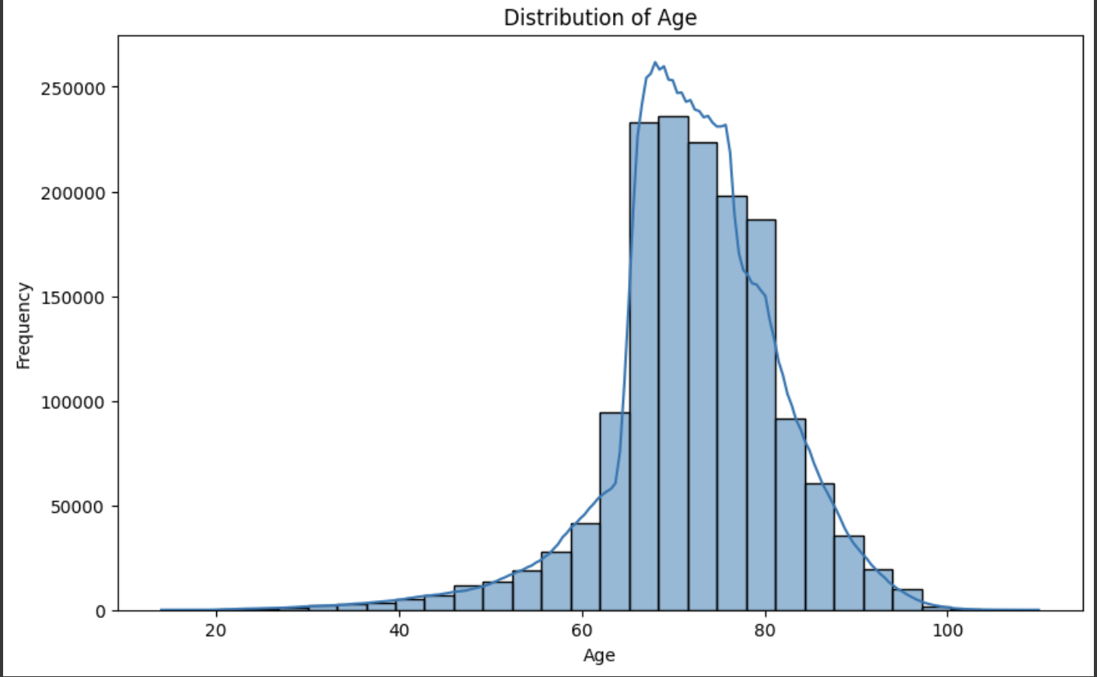

*Fig 2: Age Distribution of Members*

The age distribution graph shows that the majority of members in the dataset are aged between 65 and 80, with a smaller but significant number of members over 80. This indicates that Humana's LPPO plan serves a predominantly older population, likely in retirement or near-retirement age. These members are more likely to need regular healthcare services, including preventive care and chronic disease management. As a result, the business should focus on engaging this group by promoting preventive care visits and managing age-related health conditions. Additionally, there are relatively few younger members in the dataset, suggesting that the LPPO plan may not be as popular among younger adults. Humana might explore opportunities to attract younger members by highlighting preventive care benefits tailored to their needs. Overall, this graph highlights the need for Humana to prioritize outreach and personalized communication, particularly for its older members, to ensure they stay engaged with their healthcare providers and reduce the risk of more serious health issues down the line.

**3.3.3 Age vs Total Cost with** **Preventive Visit Gap**

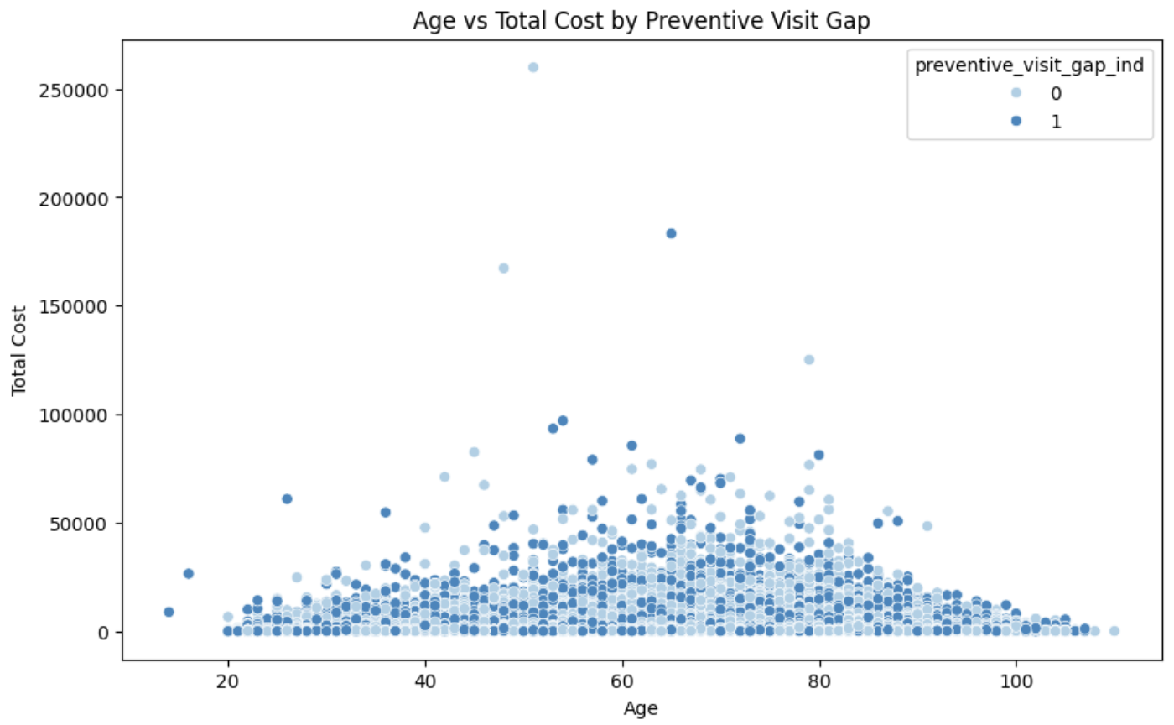

*Fig 3: Age vs Total Cost with Preventive Visit Gap*

The scatter plot shows the relationship between `age` and `total cost`, with the points color-coded by `preventive visit gap indicator`. A key observation from the graph is that, regardless of engagement in preventive visits, total costs tend to remain relatively low for most age groups. However, there are a few outliers with very high total costs, particularly in younger age groups (e.g., those in their 20s and 30s), suggesting that certain individuals incur significantly higher healthcare costs, possibly due to acute or chronic conditions. Interestingly, the majority of these high-cost members seem to have skipped preventive visits. This suggests that members who are not engaging in preventive visits might be at greater risk for costly healthcare events, reinforcing the business need for proactive outreach to encourage engagement in preventive care, particularly for younger members who may otherwise experience avoidable high healthcare costs.

**3.3.4 Compliant Ratio by Preventive Visit Gap Indicator**

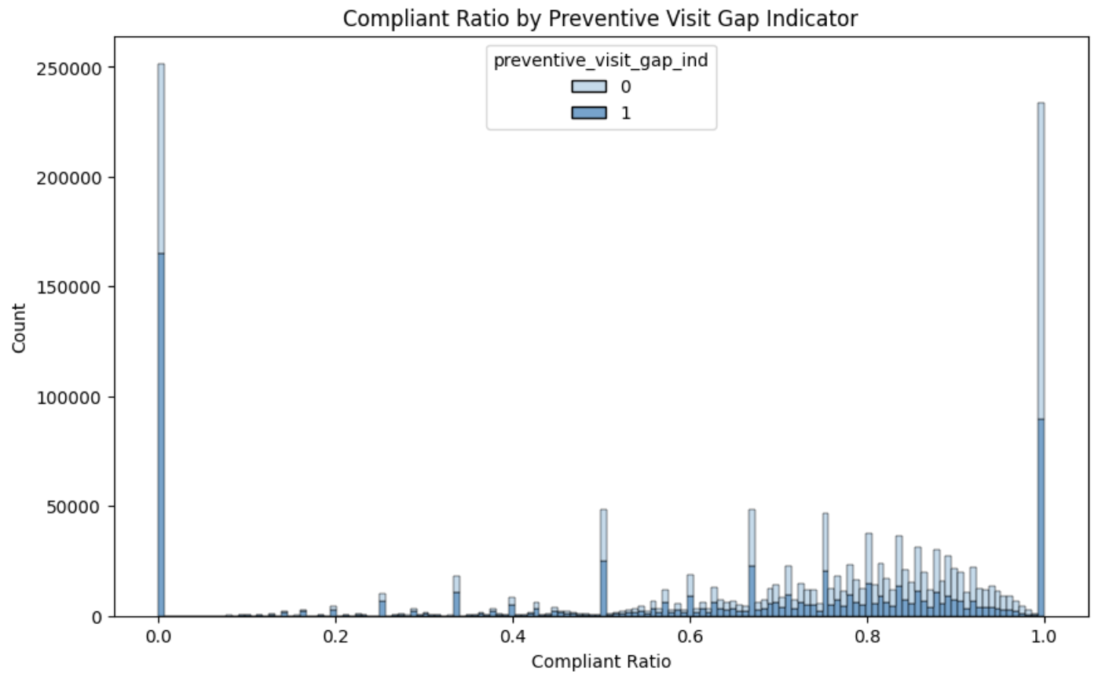

*Fig 4: Compliant Ratio by Preventive Visit Gap Indicator*

This graph shows the distribution of the `compliant ratio` across members, distinguishing those who engaged in preventive visits from those who did not. The spikes at compliant ratios of 0 and 1 suggest that many members are either fully adherent or non-adherent to their care. Members with higher compliance tend to engage more in preventive visits, while lower-compliance members are more likely to miss them. However, there is a noticeable group in the mid-range (0.4-0.8) where many members still miss preventive visits, highlighting an opportunity for targeted engagement strategies.

Focusing on this mid-range compliance group could have significant benefits. By providing additional support, reminders, or incentives to improve engagement in preventive care, Humana could reduce future healthcare costs and improve overall health outcomes, particularly for those who are partially compliant but still at risk of missing key care interventions.

**3.3.5 Average Percent Amount paid by Insurer vs Insured by Age**

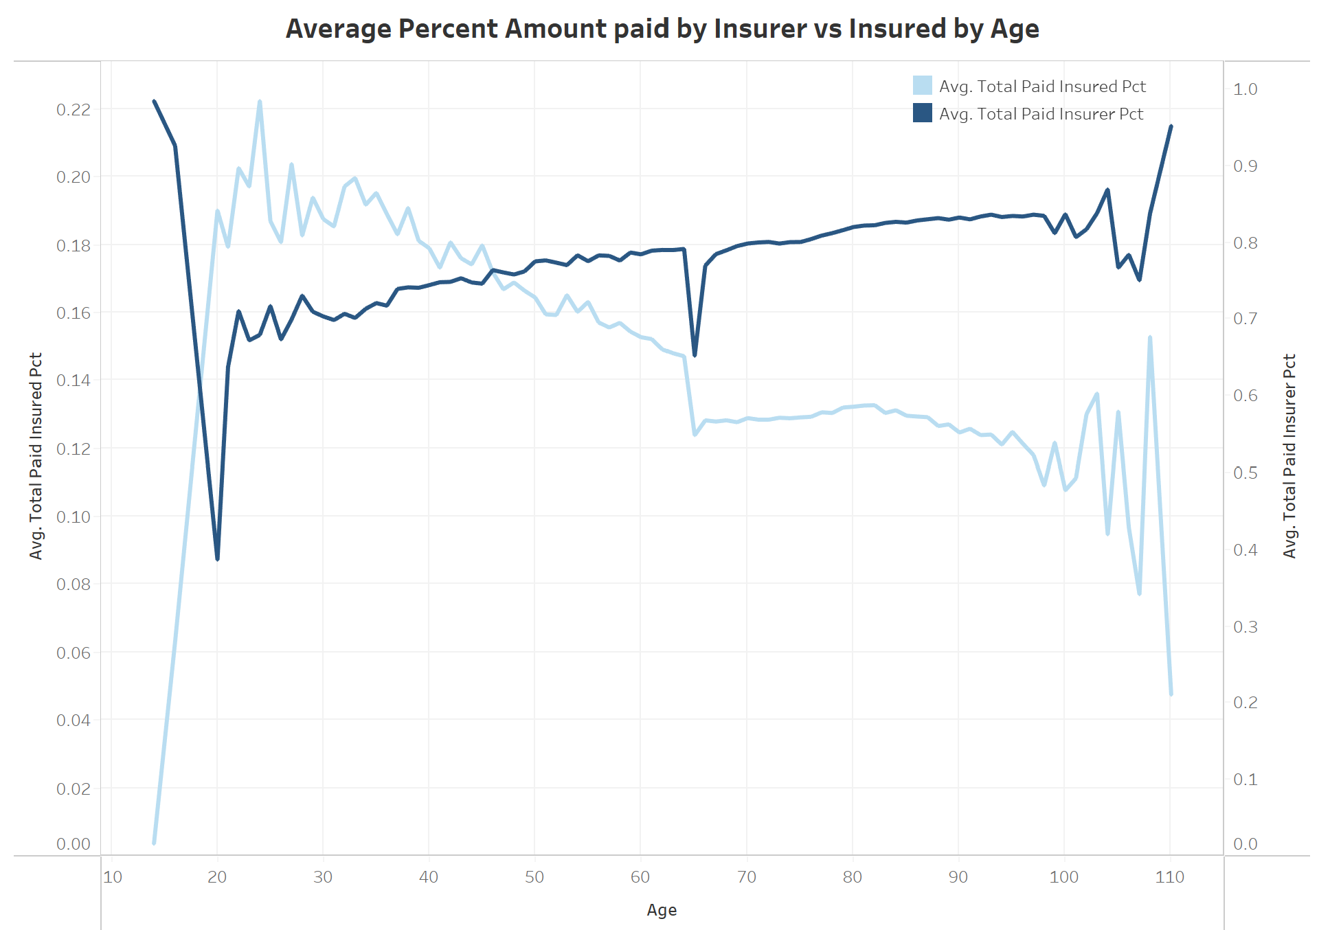

*Fig 5: Average Percent Amount paid by Insurer vs Insured by Age*

Here, we can see that as the age of a patient increases, the average percent of the total cost paid by the insurance company decreases. This could be explained by the fact that as a patient’s age increases, they require more frequent and complex medical services. According to the Medical Expenditure Panel Survey[3], 16.8% of the highest healthcare spenders were patients aged 65 and older. We see that the transition between the amount paid by the insurer vs the insured (patient) happens somewhere around the age of 45, which again reinforces our business need for proactive outreach to make sure the older patient population to engage in preventive visits which would lower the medical costs.

# 4. Statistical Analysis and Modeling

## 4.1 Model Selection

For model selection, we initially performed an 80:20 train-test split on the training dataset to ensure a robust evaluation of model performance. Given the presence of non-linearities and correlations within the dataset, we opted for tree-based models such as XGBoost, Light Gradient Boosting Model (LightGBM), and CatBoost, along with more advanced techniques like blending, stacking and deep neural networks (DNN). We evaluated these models using metrics such as the disparity score and AUC. To optimize performance, we applied cross-validation and conducted extensive hyperparameter tuning. The final model was determined based on the best performance across all these evaluations.

|  |  |  |
| --- | --- | --- |
| **Model** | **Accuracy** | **AUC Score** |
| XGBoost | 0.7021 | 0.7701 |
| Light Gradient Boosting Model | 0.6999 | 0.7708 |
| CatBoost | 0.7026 | 0.7736 |
| Blending 3 Models Above | 0.7055 | 0.7750 |
| Stacking 3 Models Above - Logistic Regression | 0.6766 | 0.7257 |
| Stacking 3 Models Above - Random Forest | 0.6665 | 0.7200 |
| Deep Neural Networks (DNN) | 0.6749 | 0.7331 |

## 4.2 Hyperparameter Optimization

We employed both Random Search and Bayesian Search for hyperparameter tuning to optimize the performance of three machine learning models: LightGBM, XGBoost, and CatBoost. The results consistently showed that Bayesian Search outperformed Random Search, as it allowed us to systematically explore the hyperparameter space and achieve superior model performance.

For LightGBM, we focused on optimizing key hyperparameters such as learning_rate, max_depth, n_estimators, subsample, colsample_bytree, num_leaves, and min_child_samples to strike a balance between model complexity and accuracy. In XGBoost, we performed 20 iterations of fine-tuning using 5-fold cross-validation to ensure robustness. The key parameters, including learning_rate, max_depth, and n_estimators, were adjusted to enhance model performance. For CatBoost, we fine-tuned hyperparameters such as learning_rate, depth, iterations, l2_leaf_reg, and border_count, aiming to optimize the model's AUC score. Similar to the other models, we ran 20 iterations with 5-fold cross-validation to ensure stable performance across different data splits.

After optimizing the models, we implemented two ensemble methods: blending and stacking, to combine predictions from LightGBM, XGBoost, and CatBoost. In the blending approach, we iterated over various weight combinations for each model’s output and selected the optimal blend by maximizing both accuracy_score and AUC on the validation set. This method effectively leveraged the strengths of each model, improving overall predictive performance. For stacking, we experimented with Random Forest and Logistic Regression as meta-learners, but the performance of stacking did not surpass that of the blending models.

## Model Results

**4.3.1 Best Performance Model**

Blends three models with the following proportions:

1. XGBoost - 36%
2. LightGBM 7%
3. CatBoost 57%

**4.3.2 Confusion Matrix**

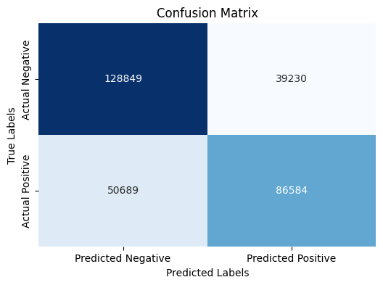

*Fig 6: Confusion Matrix*

The confusion matrix illustrates the model's performance in predicting positive and negative classes, with 128,849 True Negatives, 39,230 False Positives, 50,689 False Negatives, and 86,584 True Positives. Key metrics include an Accuracy of 70.55%, Precision of 68.82%, Recall (Sensitivity) of 63.07%, and an F1 Score of 65.82%, providing a comprehensive view of the model's classification effectiveness.

**4.3.3 ROC & Precision-Recall Curve**

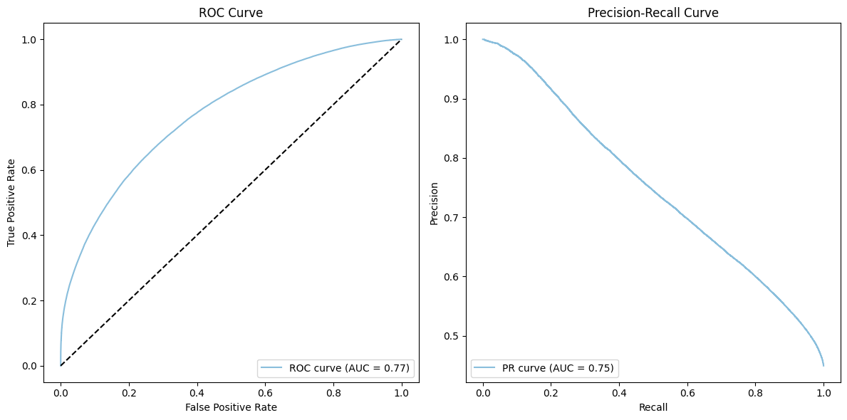

*Fig 7: ROC and Precision-Recall Curve*

The ROC curve (left) shows the model's ability to distinguish between classes, with an AUC of 0.77, indicating fair performance. The Precision-Recall curve (right) focuses on the balance between precision and recall, with an AUC of 0.75, suggesting that the model performs moderately well in identifying positive cases.

**4.3.4 Feature Importance: SHAP Values**

1. **LightGBM**

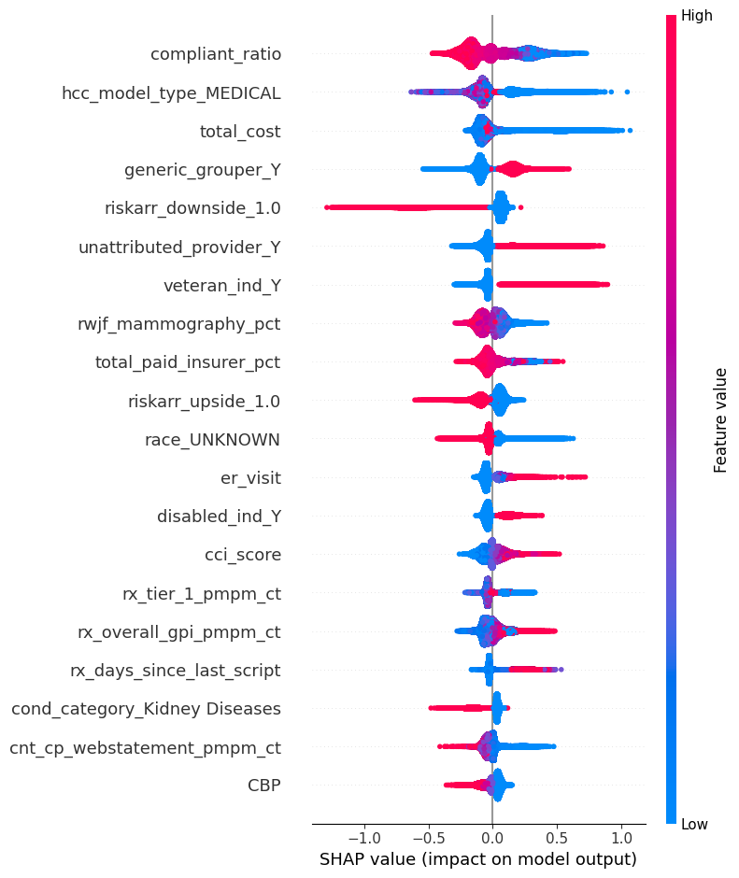

*Fig 8: SHAP Value - LightGBM*

The top 3 features impacting the LightGBM model based on SHAP values are: compliant_ratio, hcc_model_type_MEDICAL, and total_cost.

1. **XGBoost**

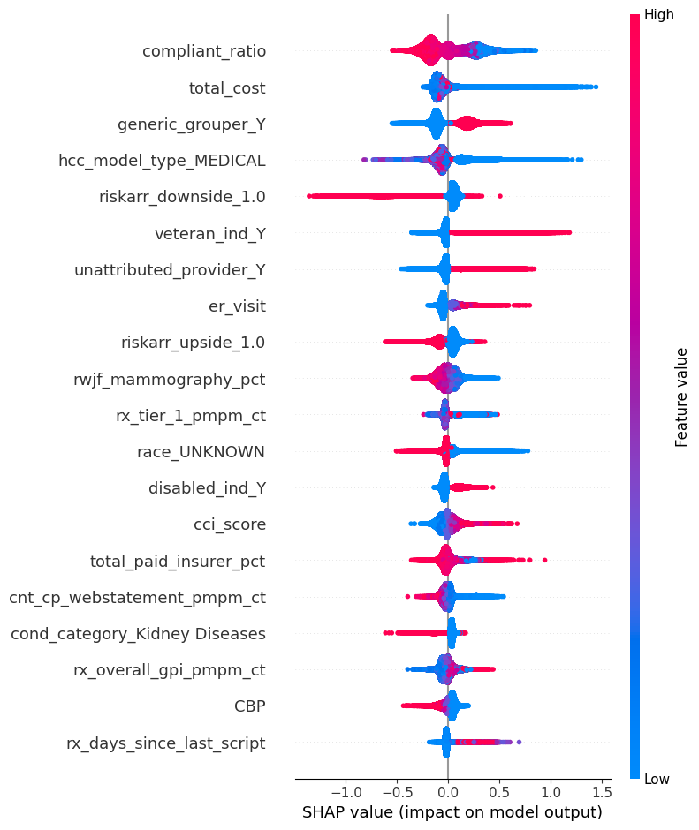

*Fig 9: SHAP Value - XGBoost*

The top 3 features impacting the XGBoost model based on SHAP values are: compliant_ratio, total_cost, and generic_grouper_Y.

1. **CatBoost**

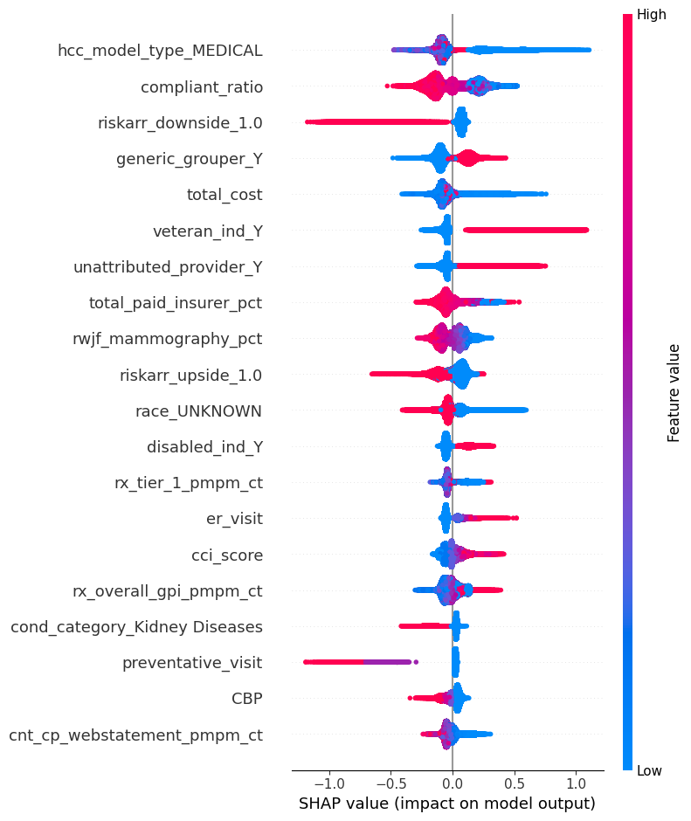

*Fig 10: SHAP Value - CatBoost*

The top 3 features impacting the CatBoost model based on SHAP values are: hcc_model_type_MEDICAL, compliant_ratio, and riskarr_downside_1.0

1. **Blending 3 Models**

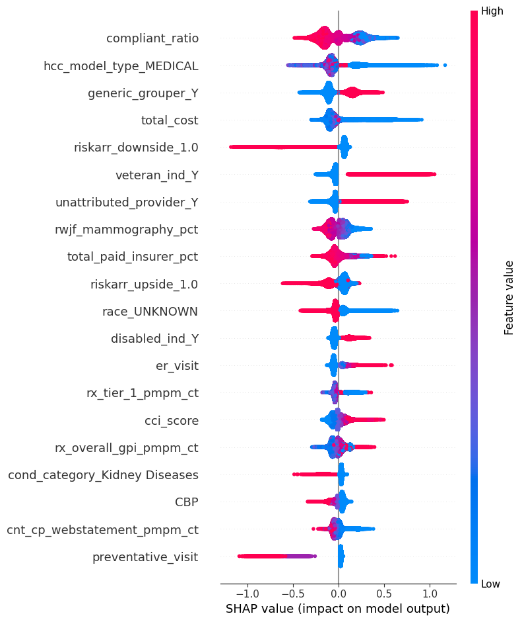

*Fig 11: SHAP Value – Blending 3 Models*

The top 3 features influencing the blended model predictions based on SHAP values are: compliant_ratio, hcc_model_type_MEDICAL, and generic_grouper_Y.

## 4.4 Model Interpretation

The SHAP plot above interprets the key factors influencing members' likelihood of engaging or not engaging in preventive visits. Positive SHAP values indicate a higher probability of non-engagement, while negative values suggest a greater likelihood of engagement. The color gradient reflects feature values, with red representing higher values and blue representing lower ones. By analyzing the SHAP plot, we can identify factors contributing to non-engagement versus those associated with higher engagement in preventive care. To clarify these patterns, we categorized the variables based on their impact on member behavior, clinical risk, and healthcare engagement.

**4.4.1 Demographics & Personal Characteristics**

Veteran status (veteran_ind_Y) indicates that veterans are slightly more likely to avoid preventive visits. Conversely, members with an unknown race (race_UNKNOWN) may disengage from preventive care, potentially due to communication barriers or being underserved. Additionally, disabled status (disabled_ind_Y) suggests that being disabled may slightly increase non-engagement, influenced by access to care and provider interaction.

**4.4.2 Healthcare Utilization & Access**

Members without an attributed provider (unattributed_provider_Y) show a significantly higher likelihood of avoiding preventive visits, highlighting the importance of provider attribution in promoting engagement. Members with a history of emergency room visits (er_visit) are also more likely to disengage, as frequent ER usage may indicate a reliance on acute care over preventive services. Interestingly, individuals with a history of prior preventive visits (preventative_visit) may show a slight decrease in engagement for future visits, possibly due to having met short-term care needs.

**4.4.3 Health Risk & Clinical Conditions**

Higher comorbidity scores (cci_score), kidney disease (cond_category_Kidney Diseases), and classification in the medical risk group (hcc_model_type_MEDICAL) all indicate disease severity and are associated with a higher likelihood of avoiding preventive care, as members with more complex health conditions prioritize immediate needs over routine visits.

**4.4.4 Behavioral & Preventive Health Engagement**

Members with higher compliance ratios (compliant_ratio) and those from populations with higher mammography screening rates (rwjf_mammography_pct) are more likely to engage in preventive care. In contrast, higher prescription counts for tier 1 medications (rx_tier_1_pmpm_ct) and overall prescriptions (rx_overall_gpi_pmpm_ct) are linked to non-engagement, suggesting a focus on managing chronic conditions over preventive visits.

**4.4.5 Financial & Insurance**

Members with higher healthcare costs (total_cost) are less likely to engage in preventive visits, likely prioritizing immediate healthcare needs over preventive measures. Additionally, those with a higher percentage of insurer-paid costs (total_paid_insurer_pct) tend to disengage slightly, perhaps because their expenses are covered, reducing their incentive to seek preventive services.

## 4.5 Clustering Analysis

Following the SHAP analysis, we classified the features influencing member engagement in preventive visits into five key categories: Demographics & Personal Characteristics, Healthcare Utilization & Access, Health Risk & Clinical Conditions, Behavioral & Preventive Health Engagement, and Financial & Insurance. We then performed a cluster analysis, grouping individuals into four distinct clusters. This clustering revealed groups with similar engagement patterns and highlighted trends in non-engagement. These insights serve as a basis for designing targeted interventions to enhance engagement, particularly among high-risk populations. The radar charts below provide a more intuitive visual understanding of the characteristics of these four clusters.

**4.5.1 Cluster Description**

| **Category** | **Cluster 0**  **Low-Need Wellness** | **Cluster 1**  **High-Risk & Critical Care** | **Cluster 2**  **Moderate Maintainers** | **Cluster 3**  **Health-Conscious & Compliant** |
| --- | --- | --- | --- | --- |
| **Unengaged in preventative care %** | 80.18% | 59.13% | 41.36% | 36.25% |
| **Demographics & Personal Characteristics** | Many veterans; few disabilities | Many with disabilities;  Smallest cluster with only 10% of members | Moderate number of veterans and disabilities | Few veterans; very few disabilities;  Largest cluster with 44 % of members |
| **Healthcare Utilization & Access** | Rare ER visits; few preventive visits | Frequent ER visits; few preventive visits | Many lack assigned providers | Frequent preventive visits |
| **Health Risk & Clinical Conditions** | Lowest risk; minimal chronic conditions | Highest risk; many with kidney disease | Moderate risk; some chronic conditions | Low risk; very few with kidney disease |
| **Behavioral & Preventive Health Engagement** | Fewer health issues, so fewer care plans needed | Often follow care plans | Usually follow care plans | Most engaged in following care plans |
| **Financial & Insurance** | Lowest overall cost; paid more by members; most tenure bands falling between 0.5-1 years and 1.5-2 years | Highest costs; most paid by insurer; most tenure bands falling between 7+ years, 1.5-2 years, and 0.5-1 years | Moderate costs; most tenure bands falling between 7+ years, 1.5-2 years, and 0.5-1 years | Lower costs; insurer pays less; most tenure bands falling between 1.5-2 years, 7+ years, and 0.5-1 years |

**4.5.2 Cluster Features – Radar Plots**

1. **Cluster 0: Low-Need Wellness**

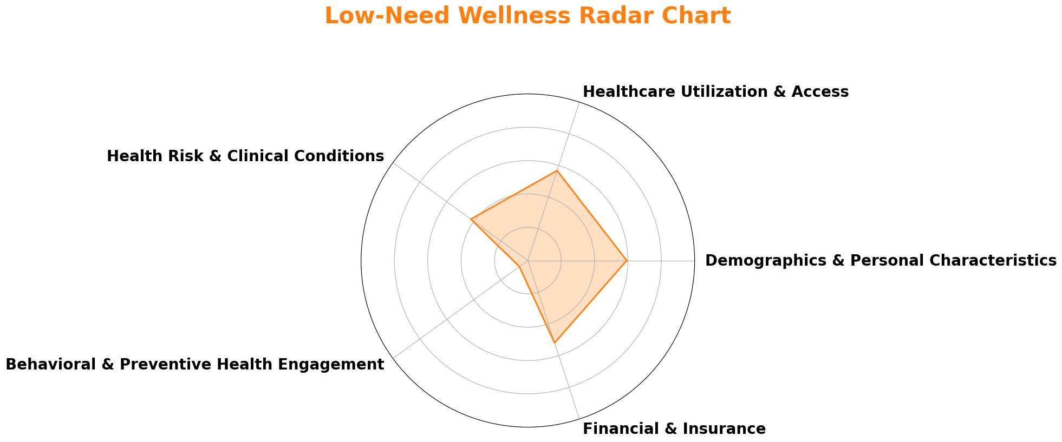

*Fig 12: Cluster 0 - Radar Chart*

1. **Cluster 1: High-Risk & Critical Care**

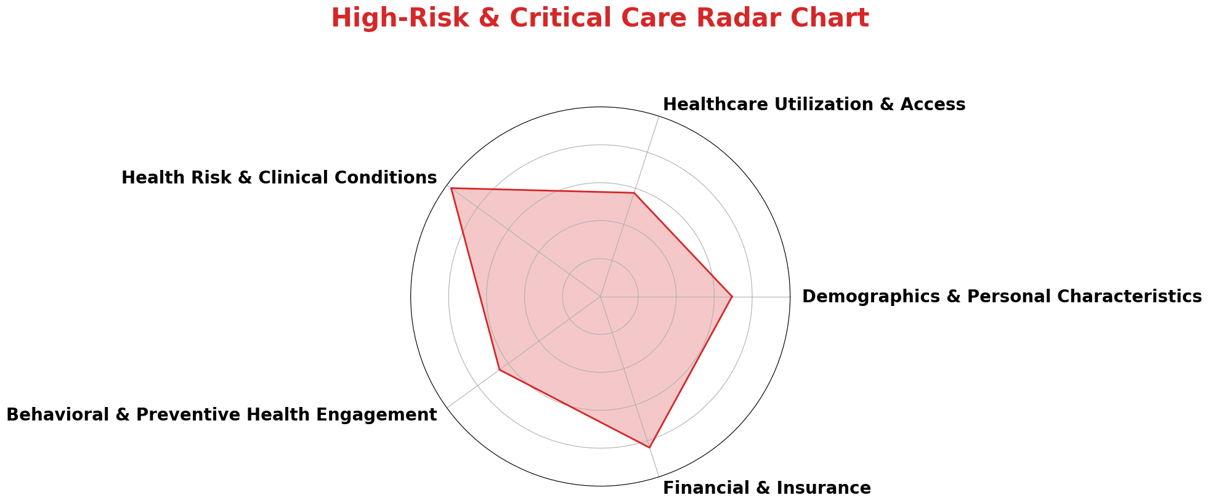

*Fig 13: Cluster 1 - Radar Chart*

1. **Cluster 2: Moderate Maintainers**

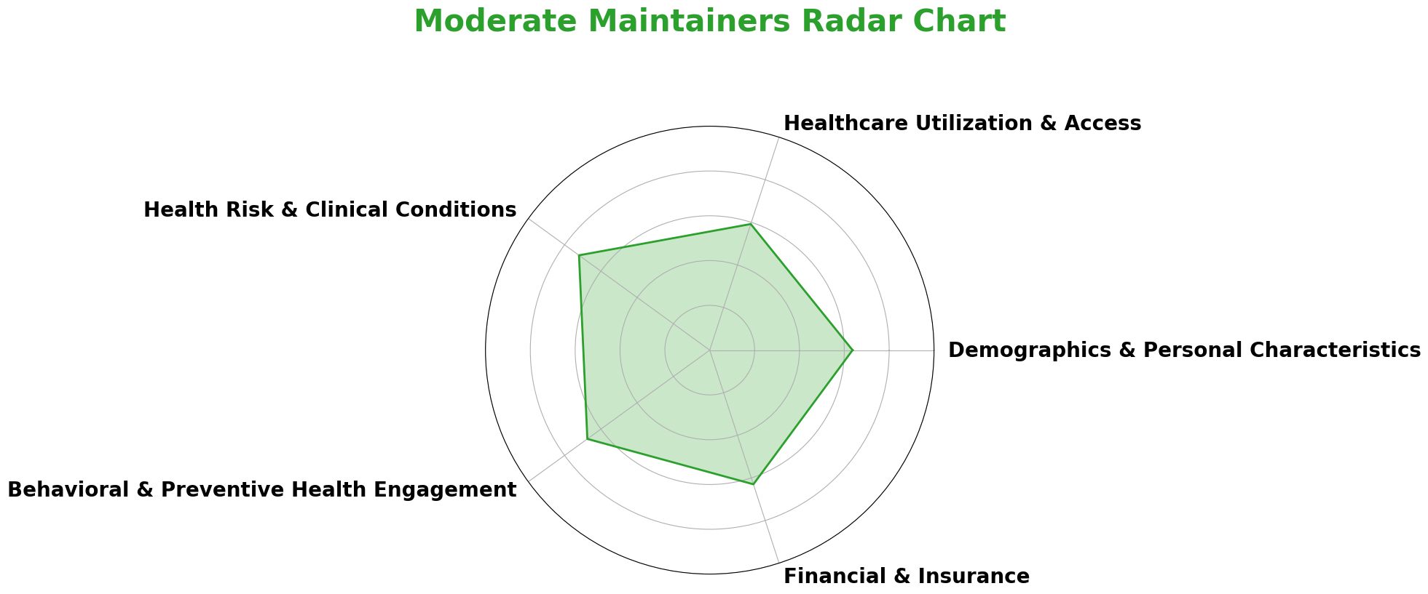

*Fig 14: Cluster 2 - Radar Chart*

1. **Cluster 3: Health-Conscious & Compliant**

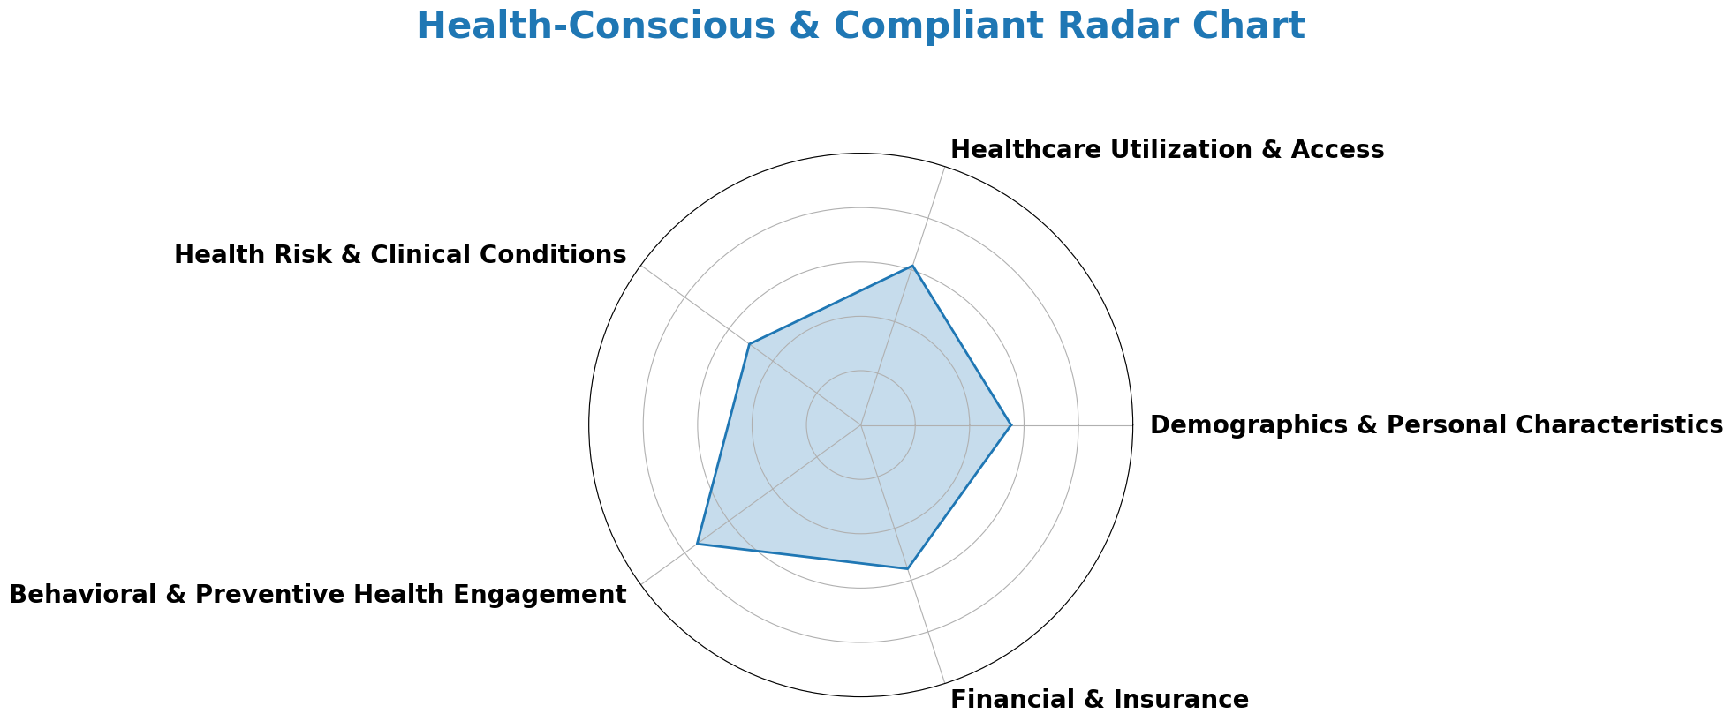

*Fig 15: Cluster 3 - Radar Chart*

# 5. Business Implications and Recommendations

## 5.1 Introduce Patient Education Programs

**5.1.1 Background**

1. **Emergency Care Overuse - Low-Need Wellness Members**

From the analysis, we observe that Cluster 0 represents individuals who generally have fewer healthcare needs and are healthier. However, they exhibit a high Emergency Room (ER) to Primary Care Provider (PCP) Ratio of 120.61, indicating a potential overreliance on ER services when primary care could be more appropriate. This group demonstrates less use of ER services overall compared to other clusters, but when healthcare is needed, they may be bypassing primary care for ER services or relying more on specialist doctors.

1. **Specialist Care Overuse - Moderate Maintainers Members**

In Cluster 2, the Specialist to PCP Ratio is 652.66, which is significantly higher, suggesting that members in this group may be over-relying on specialist care rather than primary care. This group likely seeks care from specialists for conditions that could be addressed by a PCP, potentially driving up healthcare costs and reducing care coordination.

|  |  |  |  |  |  |  |
| --- | --- | --- | --- | --- | --- | --- |
| **Cluster** | **Average_PCP_Visit** | **Average_ER_Visit** | **Average_Specialist_Visit** | **ER_to_PCP_Ratio** | **Specialist_to_PCP_Ratio** | **ER_to_Specialist_Ratio** |
| **Cluster 0: Low-Need Wellness** | Lowest | Lowest | Lowest | Highest | Lowest | Highest |
| **Cluster 1: High-Risk & Critical Care** | Highest | Highest | Highest | High | Highest | High |
| **Cluster 2: Moderate Maintainers** | High | High | High | Low | High | Low |
| **Cluster 3: Health-Conscious & Compliant** | Low | Low | Low | Lowest | Low | Lowest |

**5.1.2 Proposed Strategies for Humana**

Humana can improve patient outcomes and reduce unnecessary healthcare costs by implementing comprehensive education programs to help members distinguish between primary care, emergency care, and specialist care. This initiative should specifically address the overuse of emergency services and specialist visits, providing members with the knowledge to use each service type appropriately.

To clarify the distinction between these services, Humana should emphasize the crucial role of Primary Care Providers (PCPs) in managing general healthcare needs and minimizing reliance on emergency rooms. Developing educational resources—such as flyers, emails, and content on patient portals—will help members understand when an ER visit is necessary versus when a PCP appointment is more appropriate. Strengthening communication to promote long-term relationships with PCPs will ensure they become the primary point of contact for most healthcare needs. This is especially important for Cluster 0: Low-Need Wellness, where the high ER-to-PCP ratio indicates overuse of emergency services. Additionally, Humana should offer targeted education for members in Cluster 2: Moderate Maintainers, clarifying when specialist care is necessary and when a PCP can manage their condition. Workshops or virtual sessions explaining when to consult a PCP first would further support routine check-ups and improve care coordination, helping to reduce unnecessary specialist visits and overall healthcare costs.

To reinforce these efforts, Humana can launch awareness campaigns aimed at members with high ER-to-PCP and Specialist-to-PCP ratios, improving their understanding of how to navigate the healthcare system. By utilizing digital platforms like the Humana app, personalized notifications, reminders, and educational content can be delivered directly to members, encouraging them to engage with their PCPs before seeking specialist or emergency care. This proactive communication strategy would enhance member engagement, lower the reliance on costly healthcare services, and provide overall benefits to both the members and the healthcare system.

## Personalized Preventive Care Plans

**5.2.1 Background**

1. **Veterans and Disabled Members**

Veterans and disabled individuals often encounter significant psychological and emotional barriers that hinder their engagement in preventive care[4]. Many veterans grapple with unique psychological challenges such as post-traumatic stress disorder (PTSD), depression, and anxiety, which can make it difficult for them to seek the care they need. Veterans who experience mental health problems but do not seek treatment often believe that the problem is not serious or that they can handle it independently, delaying necessary care[5]. Many veterans rely on Veterans Health Administration (VHA) providers as their primary source of care, making them less likely to engage with other healthcare services outside of the VHA system[6]. This reliance may contribute to a lower perceived need for non-VHA preventive services. For disabled individuals, the emotional toll of living with chronic conditions can lead to feelings of helplessness or apathy, significantly reducing their motivation to participate in preventive health measures.

Moreover, social determinants such as income, education, and community support can significantly influence health participation. Veterans may have difficulty transitioning to civilian life, impacting their socioeconomic stability and access to resources. Members with disabilities often face discrimination, social isolation, and physical barriers to accessing care, further limiting their ability to engage with healthcare services[7]. Together, these factors create a cycle of disengagement from preventive care, perpetuating health disparities within these vulnerable groups.

1. **High-Risk & Critical Care**

Members with chronic conditions or high medical costs, such as those with more serious illnesses or kidney disease, often prioritize immediate health needs over preventive care. For example, in our clustering analysis result, the average Charlson Comorbidity Index (CCI) score of the High-Risk & Critical Care Cluster is 7.2, indicating a severe level (with a score of 5 or higher considered severe). This suggests a higher mortality risk and a greater likelihood of poor health outcomes. These members often deal with multiple comorbidities and are more likely to seek specialized care rather than focusing on preventive measures. This pattern is also reflected in their total healthcare costs, which can be nearly three times the average. Additionally, individuals living in remote areas are less likely to access preventive care due to geographical barriers and limited healthcare resources[8]. Implementing care programs that emphasize preventive services could significantly improve their health outcomes.

This focus on urgent care stems from the complexities of managing ongoing health issues, which can overshadow the importance of routine preventive services. The pressure to address acute symptoms and complications often leads these individuals to neglect regular screenings and check-ups, which are essential for early detection and long-term health management. As a result, this pattern not only increases their risk of disease progression but also leads to higher healthcare costs over time, as late-stage interventions tend to be more expensive and less effective than preventive care[9]. By shifting the focus to comprehensive care approaches that highlight the value of preventive services, healthcare providers can assist these members in balancing their immediate health concerns with the need for proactive health management.

**5.2.2 Proposed Strategies for Humana**

To effectively address the psychological, emotional, and practical barriers that veterans and individuals with disabilities face in accessing preventive care, Humana should consider implementing tailored outreach programs designed specifically for these populations. For veterans, this could include providing mental health resources, such as counseling services for conditions like post-traumatic stress disorder (PTSD) or anxiety, while emphasizing the importance of early intervention. For disabled individuals, the focus could be on offering guidance around preventive services, acknowledging the emotional challenges associated with chronic illness. Personalized outreach efforts would help reduce feelings of helplessness and disengagement, while fostering greater participation in preventive health measures. By actively promoting these programs, especially within the LPPO (Local Preferred Provider Organization) framework, Humana can ensure these populations are aware of available virtual and physical healthcare resources, creating a more inclusive and accessible healthcare environment. Integrating these services into existing outreach initiatives will provide much-needed tailored support, making it easier for veterans and individuals with disabilities to engage in preventive care.

Additionally, for High-Risk & Critical Care members, Humana could develop personalized preventive care plans that balance short-term care with long-term health management. These plans would focus on services such as regular screenings, diabetic eye exams, mammograms, bone density tests, telehealth check-ins, and proactive health coaching. By encouraging members to participate in preventive measures, the plans would help reduce the risk of disease progression and minimize the need for costly interventions in the future. Humana already promotes preventive services, such as annual diabetic retinal exams, mammograms, and bone mineral density tests, at low or no cost to members. For example, diabetes patients under Humana Medicare Advantage plans can access free in-office or at-home diabetic retinal exams once a year[10]. For breast cancer prevention, Humana covers annual mammograms with no out-of-pocket costs for members starting at age 40, while also providing access to low-cost or free mammograms for low-income or uninsured women[11]. Humana also offers bone mineral density tests for individuals at risk for osteoporosis or those who have recently suffered a fracture[12]. Enhancing communication with high-risk members through regular reminders and follow-ups would further boost engagement in these services. Programs such as post-ER visit follow-ups, disease management plans (e.g., for diabetes or kidney disease), and access to care navigators could help shift the focus from acute care to preventive care, improving health outcomes and reducing overall healthcare costs over time.

## 5.3 Removing Barriers for Better Healthcare Access

**5.3.1 Background**

Individuals who are in high-risk and need Critical Care, as well as veterans and disabled members, often encounter a range of obstacles that impede their ability to access healthcare services. For those who are severely ill, physical limitations such as chronic pain, fatigue, or mobility issues can make it extremely difficult to leave their homes for in-person visits. Veterans and disabled individuals, on the other hand, frequently face not only physical barriers but also psychological ones. Mental health conditions such as anxiety, depression, and post-traumatic stress disorder (PTSD) can create significant reluctance or even fear around seeking care outside of their familiar environments. Additionally, the emotional toll of managing chronic conditions can lead to feelings of isolation and hopelessness, further discouraging engagement in necessary healthcare.

Beyond psychological barriers, practical challenges also play a role in preventing disabled individuals from accessing healthcare. Mobility issues, lack of accessible transportation, and physical barriers in healthcare facilities can severely limit their ability to attend appointments. These compounded barriers often result in delayed or missed care, avoidance of preventive services, and a reduced focus on routine health maintenance, ultimately leading to worsened health outcomes. Over time, this exacerbates existing conditions, increases the likelihood of hospitalizations, and places additional strain on the healthcare system as more urgent and intensive interventions become necessary.

**5.3.2 Proposed Strategies for Humana**

To address these challenges, Humana could broaden its existing healthcare access programs[13] by tailoring specific solutions to meet the needs of high-risk and critical care members, as well as veterans and disabled populations. A key recommendation is to enhance virtual healthcare offerings, including telemedicine and telerehabilitation, to make care more accessible to those who are unable to leave their homes easily. Virtual care options enable these members to receive regular check-ups, consultations, and follow-up care without the logistical and emotional strain of traveling to a healthcare facility. This approach would be especially beneficial for veterans and individuals with mental health conditions, providing a more accessible and less stressful way to engage with care and maintain their health.

Another essential solution is to offer transportation assistance for members who require in-person visits. This could include providing free or subsidized transportation to and from healthcare facilities, focusing on individuals with mobility challenges, or those living in rural areas. By alleviating the transportation burden, Humana can ensure that members facing geographic or physical barriers can access necessary medical services in a timely manner.

Expanding these initiatives, along with targeted communication to these vulnerable groups about available services, would not only improve engagement in preventive care but also reduce the risk of complications and hospitalizations. These measures would promote consistent health management and shift the focus from reactive, crisis-based care to proactive, preventive healthcare, easing the overall burden on the healthcare system.

## 5.4 Strengthening PCP Roles to Prevent Fragmented Care

**5.4.1 Background**

Many members lack an attributed primary care provider (PCP), which significantly limits their access to timely interventions and preventive care. Without a PCP, members miss out on essential services such as screenings, vaccinations, and routine check-ups, increasing their risk of complications and poor health outcomes. Additionally, the absence of a PCP often leads members to rely on emergency services for urgent issues that could have been addressed earlier in a primary care setting. This reactive approach not only increases healthcare costs but also fragments care, as emergency room visits lack the continuity necessary to effectively manage chronic conditions.

A lack of follow-up reminders further compounds the problem, contributing to missed appointments and neglected health needs. Without consistent communication from a PCP, members may forget scheduled visits or fail to understand the importance of regular screenings. This disjointed approach to health management results in a fragmented care experience, where members lack comprehensive support and fall into a cycle of reactive care that exacerbates health issues, increasing their reliance on emergency services.

Data shows that after an initial visit with a PCP, members' healthcare patterns change, with a notable decrease in emergency room visits and reduced reliance on specialists. This suggests that early engagement with PCPs helps members manage their health proactively, preventing conditions from escalating into emergencies. PCPs play a crucial role in identifying potential health issues early, enabling timely interventions before conditions worsen. By offering personalized care, appropriate referrals to specialists, and regular follow-ups, PCPs ensure that members receive continuous, comprehensive support. In contrast, members without PCP engagement are more likely to bypass primary care altogether, turning to expensive and less efficient emergency services for acute issues that could have been managed through routine care. This reactive model not only raises healthcare costs but also contributes to fragmented care, as the absence of a central coordinating provider leads to missed opportunities for effective chronic condition management. The following plots show the department-wise average number of visits:

1. For people who have at-least one PCP visit: Department-wise average number of following visits in the dataset (pcp_visit ≥ 1)

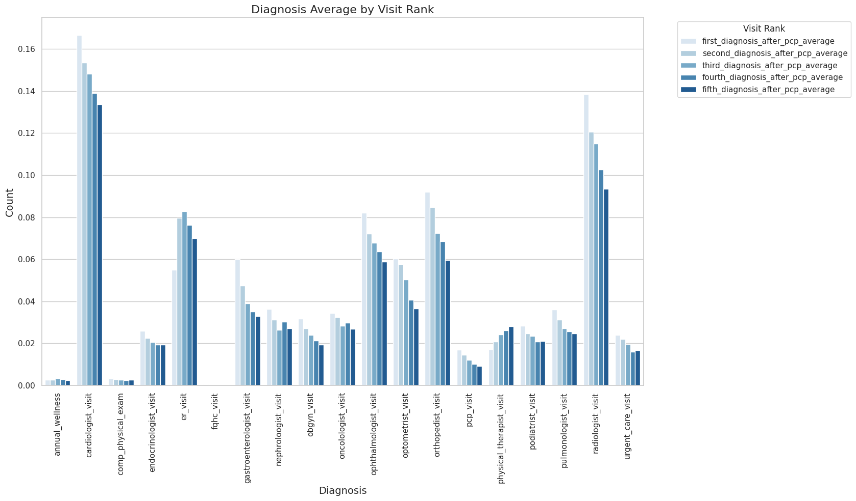

*Fig 16: Average number of following visits*

1. For people who have no PCP visits: Department-wise average number of visits (up to 5) in the dataset (pcp_visit = 0)

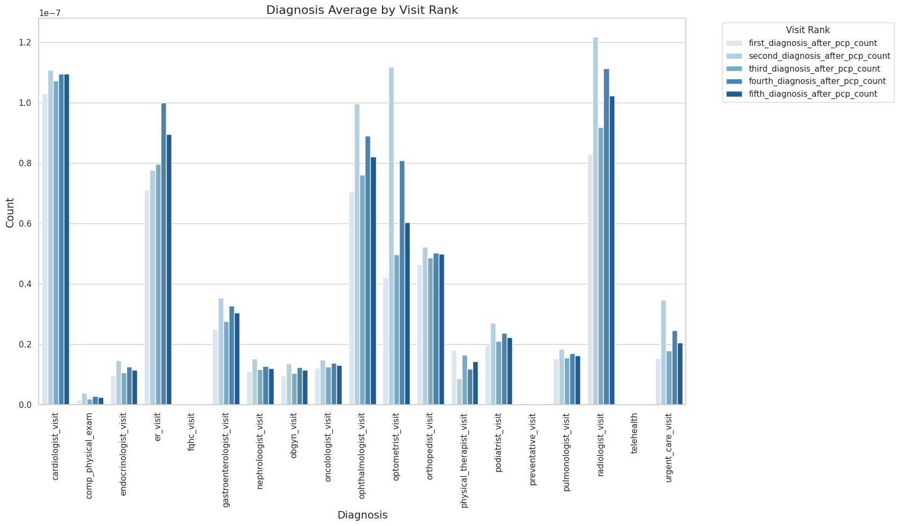

*Fig 17: Average number of visits (up to 5)*

The combination of limited PCP attribution, declining PCP engagement, and increased reliance on emergency care highlights a critical gap in the continuity of care. Without strong PCP involvement, members face greater vulnerability to poor health outcomes, and healthcare costs rise as preventive care is replaced by reactive interventions. To address this issue, it is essential to reinforce the role of PCPs as central coordinators of care, ensuring they remain consistently engaged with members for ongoing health management. By doing so, healthcare systems can reduce fragmentation, lower costs, and improve long-term health outcomes.

**5.4.2 Proposed Strategies for Humana**

To improve long-term health outcomes and reduce fragmented care, Humana should prioritize strategies that strengthen the role of primary care providers (PCPs) as central coordinators of care, especially for Cluster 2: Moderate Maintainers, who exhibit a relatively high Specialist to PCP Ratio. This indicates a frequent reliance on specialists over PCPs, highlighting the need for better care coordination. Enhancing communication between PCPs and specialists is essential. When members are referred to specialists, clear communication channels between both providers will allow PCPs to stay informed about patient progress and treatment plans. This will ensure continuous PCP involvement in managing chronic conditions, reduce fragmented care, and allow for timely interventions, ultimately fostering a more cohesive healthcare experience for members.

In addition, providing specialized training and support for PCPs to manage complex chronic conditions in collaboration with specialists can empower them to offer more comprehensive care. This collaborative approach enhances care quality by ensuring holistic management of member health, while also reducing dependence on reactive, costly emergency interventions.

To further strengthen PCP roles, Humana should implement regular follow-up programs. For example, scheduling follow-up appointments with PCPs immediately after specialist visits can help re-engage members with their primary care provider and promote ongoing health management. This strategy can also be implemented during the patient’s ER visits. The average current ER wait-time is almost 3 hours in the United States, which could also be shortened by effective communication with the patients ensuring that they schedule and attend follow-up appointments with their PCPs[14]. Continuity of care enhances patient communication, improves health knowledge, and provides consistent support, especially during critical early stages of treatment. By fostering these ongoing interactions, Humana can ensure that members build and maintain a trusting relationship with their PCPs, reducing over-reliance on specialists and emergency services, and leading to better health outcomes in the long term.

## 5.5 Incentivize Preventive Care & Outreach

**5.5.1 Background**

Preventive care is significantly more cost-effective than treating severe or advanced conditions, yet many members, particularly those in Low-Need Wellness and Health-Conscious & Compliant groups, underutilize these services. Both groups exhibit lower rates of preventive care visits and a notable discrepancy between visits to primary care providers (PCPs) and specialists. Even though these members are generally more health-conscious, their overall participation in screenings and routine check-ups remains low, leaving potential health risks unaddressed.

To improve engagement in preventive care and reduce future healthcare costs, Humana should implement strategies that incentivize proactive health management. By offering rewards for completing preventive screenings and emphasizing the long-term benefits of routine check-ups, Humana can positively influence member behavior, leading to improved health outcomes over time.

**5.5.2 Proposed Strategies for Humana**

Humana can boost participation in preventive care by offering financial incentives to members in the Low-Need Wellness and Health-Conscious & Compliant groups for completing routine screenings, wellness check-ups, and vaccinations. Incentives such as premium discounts, wellness credits, or gift cards are effective motivators, encouraging members to take a more active role in managing their health. By providing tangible rewards for engaging in preventive care, Humana can increase participation rates and help reduce future healthcare costs associated with treating preventable conditions.

In addition to financial incentives, Humana could streamline its four existing apps[15]—MyHumana, Go365, CenterWell Pharmacy, and Go365 for Humana Healthy Horizons—into a unified platform that offers reminders and tracks health progress. This integration would simplify healthcare management for members, enabling them to receive timely notifications about screenings or check-ups and monitor their preventive care milestones. By reinforcing proactive healthcare management, the tool would help members stay on top of their health more efficiently.

Targeted outreach should be prioritized for these member groups, as their engagement in preventive care tends to be lower. Personalized communication strategies, such as reminders and wellness campaigns, can emphasize both the immediate incentives and long-term health benefits of preventive care. Additionally, the Humana app could incorporate fun, interactive activities, encouraging members to check in regularly and participate in friendly competitions or challenges with family and friends. This approach would not only strengthen Humana's relationship with members but also motivate them to stay engaged with their health, view their progress, and receive timely appointment reminders. By focusing on these groups, Humana can promote more proactive health behaviors, leading to better health outcomes and reducing the reliance on costly reactive treatments.

Additionally, analysis shows that Humana can enhance its information delivery through the web statement platform, where member interactions are significantly higher compared to other communication channels such as emails, print, or VAT. Leveraging the web statement platform for outreach can improve communication effectiveness, ensuring that the incentives and benefits of preventive care are clearly conveyed, resulting in higher engagement and participation.

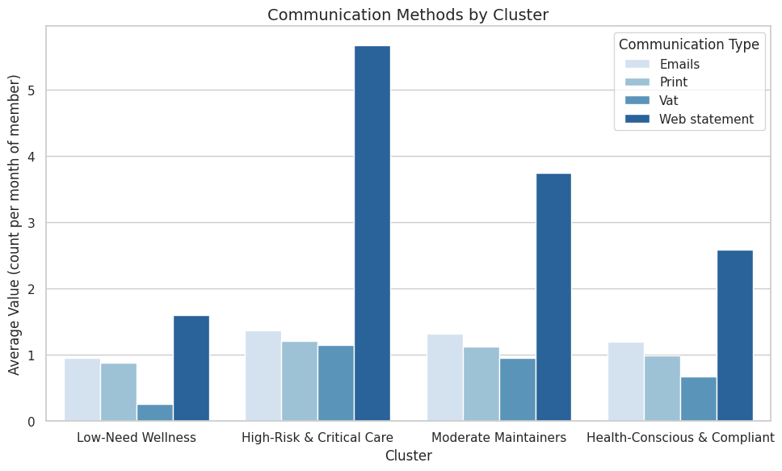

*Fig 18: Existing Communication Methods for each Cluster*

## 5.6 Maximizing Health Outcomes and Reducing Costs through PCP Engagement

**5.6.1 Background**

Building strong connections between patients and their Primary Care Physicians (PCPs) is crucial not only for improving patient health outcomes but also for driving significant financial benefits for healthcare organizations like Humana. PCPs play a vital role in proactive health management, offering preventative care that can mitigate the need for costly treatments, reduce hospital admissions, and prevent serious health issues from escalating. By strengthening the relationship between members and their PCPs, Humana can not only improve health outcomes but also achieve considerable cost savings.

The following analysis highlights the relationship between the number of PCP visits and average monthly medical costs across four patient clusters: High-Risk & Critical Care, Health-Conscious & Compliant, Low-Need Wellness, and Moderate Maintainers. The data demonstrates the potential for significant cost reductions through increased PCP visits. Specifically, the analysis shows a consistent pattern: as the number of PCP visits increases, the average monthly medical cost decreases. This effect is particularly noticeable in the High-Risk & Critical Care cluster.

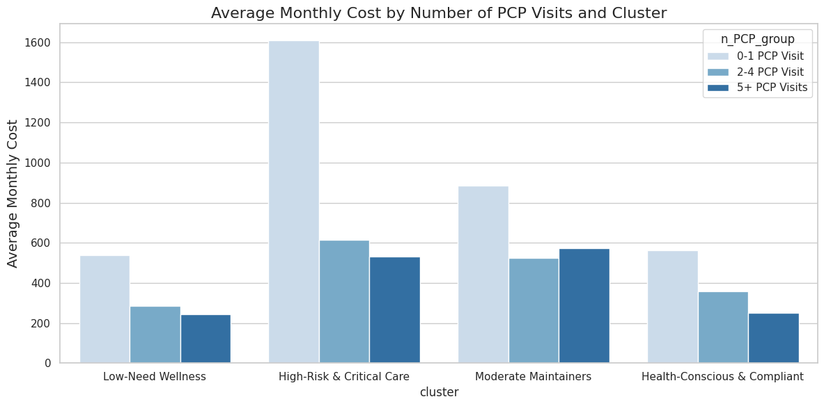

*Fig 19: Average Monthly Cost by number of PCP Visits for each Cluster*

**5.6.2 Cost and Savings Calculations for Humana**

|  |  |  |  |  |  |  |  |
| --- | --- | --- | --- | --- | --- | --- | --- |
| **PCP Visit Tiers** | **Population Count** | **Avg. Monthly Cost** | **Total Cost  (Population × Avg. Cost)** | **Overall Savings compared to Previous Tier** | **Percentage paid by Humana** | **Total Cost paid by Humana** | **Savings compared to Previous Tier for Humana** |
|  | **High-Risk & Critical Care** | | | | | | |
| **Tier 1** | 32,954 | 1,611 | 5,30,76,450 | **-** | 85.32% | 4,52,84,462 | - |
| **Tier 2** | 616 | 2,02,85,892 | **-3,27,90,558** | 1,73,07,784 | **-2,79,76,679** |
| **Tier 3** | 530 | 1,74,63,193 | **-28,22,699** | 1,48,99,476 | **-24,08,307** |
|  | **Health-Conscious & Compliant** | | | | | | |
| **Tier 1** | 1,50,110 | 563 | 8,45,92,374 | **-** | 83.55% | 7,06,77,607 | - |
| **Tier 2** | 359 | 5,38,38,694 | **-3,07,53,680** | 4,49,82,660 | **-2,56,94,946** |
| **Tier 3** | 251 | 3,76,62,697 | **-1,61,75,997** | 3,14,67,485 | **-1,35,15,175** |
|  | **Low-Need Wellness** | | | | | | |
| **Tier 1** | 41,357 | 537 | 2,22,12,570 | **-** | 75.92% | 1,68,63,258 | - |
| **Tier 2** | 284 | 1,17,62,099 | **-1,04,50,471** | 89,29,507 | **-79,33,751** |
| **Tier 3** | 245 | 1,01,43,152 | **-16,18,947** | 77,00,441 | **-12,29,066** |
|  | **Moderate Maintainers** | | | | | | |
| **Tier 1** | 1,07,610 | 886 | 9,53,59,743 | **-** | 84.27% | 8,03,60,569 | - |
| **Tier 2** | 525 | 5,64,21,228 | **-3,89,38,515** | 4,75,46,709 | **-3,28,13,860** |
| **Tier 3** | 572 | 6,14,92,939 | **50,71,711** | 5,18,20,689 | **42,73,979** |

|  |  |
| --- | --- |
| **Key:** |  |
| **Tier 1** | **0-1 PCP Visit** |
| **Tier 2** | **2-3 PCP Visit** |
| **Tier 3** | **5+ PCP Visits** |

1. **Impact of PCP Visits on Cost**

Across all clusters, an increase in PCP visits corresponds to a significant reduction in average monthly medical costs. The pattern is consistent: as patients engage more frequently with their PCPs, their healthcare is better managed, which leads to lower overall costs. Preventive care, regular monitoring, and timely interventions are likely reasons for this trend.

For instance, in the High-Risk & Critical Care cluster, which typically includes members with more complex and chronic conditions, the average monthly cost per member drops sharply from $1,611 for 0-1 PCP visits to just $529 for members with 5+ visits. This significant decrease reflects the crucial role that continuous, proactive care plays in managing these patients’ health and preventing costly emergency interventions. Other clusters, though not as high-risk, exhibit a similar downward trend, confirming that frequent PCP visits can help control healthcare costs across different population groups.

Furthermore, the Moderate Maintainers group, while having a higher cost for 5+ visits compared to 2-3 visits, still benefits from proactive health management. These members may require more intensive treatment or have conditions that demand closer monitoring, which, while raising short-term costs, could prevent more expensive long-term complications.

1. **Potential Savings**

Encouraging members to increase their PCP visits holds immense potential for financial savings. Within the Health-Conscious & Compliant group, transitioning from 0-1 PCP visits to 2-3 visits leads to a reduction in average monthly costs from $563 to $358. When applied across the entire population of this group, this translates into savings of over $30 million per month.

Similarly, in the High-Risk & Critical Care group, the potential savings are even greater. Shifting all members from 0-1 visits to 5+ visits would reduce monthly costs by approximately $35.6 million. These savings highlight the importance of engaging high-risk members in more frequent PCP visits, where the financial impact is most pronounced.

Moreover, the Low-Need Wellness cluster, which consists of generally healthier individuals, also benefits from increased PCP engagement. Though their baseline costs are lower, moving this group to more frequent PCP visits can save nearly $11 million monthly—savings that, when aggregated across all clusters, become substantial.

1. **Cluster with the Most Savings**

The High-Risk & Critical Care cluster offers the greatest potential for cost reduction. With an inherently higher baseline medical cost due to the complexity of these members' conditions, increasing the number of PCP visits has a profound effect. Moving all members in this cluster from 0-1 visits to 5+ visits would decrease the total monthly cost by nearly $35.6 million. This underscores the importance of preventive care and regular monitoring for high-risk populations, not only from a cost perspective but also in terms of improving health outcomes and quality of life.

**5.6.3 Overall Potential Savings**

Total cost across all clusters if all members have 0-1 PCP visits:

* $53,076,450 + $84,592,374 + $22,212,570 + $95,359,743 = $255,241,137

Total cost across all clusters if all members have 2-3 PCP visits:

* $20,285,892 + $53,838,694 + $11,762,099 + $56,421,228. = $142,307,913
* Savings = $255,241,137 - $142,307,913 **= $112,933,224**

Total cost across all clusters if all members have 5+ PCP visits:

* $17,463,193 + $37,662,697 + $10,143,152 + $61,492,939 = $126,762,981
* Savings = $255,241,137 - $126,762,981 = **$128,478,156**

**5.6.4 Potential Savings for Humana**

Total cost across all clusters if all members have 0-1 PCP visits:

* $45,284,462 + $70,677,607+ $16,863,258 + $80,360,569 = $213,185,896

Total cost across all clusters if all members have 2-3 PCP visits:

* $17,307,784 + $44,982,660 + $8,929,507 + $47,546,709 = $118,766,660
* Savings = $213,185,896 - $118,766,660 = $94,419,236

Total cost across all clusters if all members have 5+ PCP visits:

* $14,899,476 + $31,467,485 + $7,700,441 + $51,820,689 = $105,888,091
* Savings =$213,185,896 - $105,888,091 = $107,297,805

**5.6.4 Proposed Strategies for Humana**

If Humana can encourage all members to have at least 5+ PCP visits, the company can reduce overall monthly costs from $213.2 million to $107.3 million — an almost 50% reduction, especially in high-risk groups like High-Risk & Critical Care. Even encouraging 2-3 PCP visits instead of none would yield significant savings across all clusters. Encouraging more frequent PCP visits would also lead to indirect benefits, such as reducing hospital admissions, emergency room visits, and the use of specialist services—all of which are significantly more expensive than primary care. With better PCP engagement, early detection of health issues becomes more feasible, and chronic conditions can be managed more effectively, leading to fewer costly complications down the road.

# 6. Conclusion

References

1. https://calmatters.org/projects/californias-worsening-physician-shortage-doctors/#:~:text=California%20is%20facing%20a%20growing,and%20those%20without%20health%20coverage
2. https://www.ksby.com/news/local-news/cant-get-in-to-see-the-doctor-why-theres-a-physician-shortage-and-whats-being-done-about-it#:~:text=Across%20the%20country%2C%20and%20the,from%20the%20Kaiser%20Family%20Foundation.
3. https://meps.ahrq.gov/data_files/publications/st533/stat533.shtml
4. Zinzow, H. M., Britt, T. W., McFadden, A. C., Burnette, C. M., & Gillispie, S. (2012). Connecting active duty and returning veterans to mental health treatment: Interventions and treatment adaptations that may reduce barriers to care. Clinical psychology review, 32(8), 741-753.
5. Britt, T. W., Bennett, E. A., Crabtree, M., Haugh, C., Oliver, K., McFadden, A., & Pury, C. L. (2011). The theory of planned behavior and reserve component veteran treatment seeking. Military Psychology, 23(1), 82-96.
6. Thomas, B., Thadani, A., Chen, P. V., Christie, I. C., Kern, L. M., Rajan, M., ... & Helmer, D. A. (2022). Veterans’ ambulatory care experience during COVID-19: veterans’ access to and satisfaction with primary care early in the pandemic. BMC Primary Care, 23(1), 245.
7. Hamilton, N., Olumolade, O., Aittama, M., Samoray, O., Khan, M., Wasserman, J. A., ... & Ragina, N. (2022). Access barriers to healthcare for people living with disabilities. Journal of Public Health, 1-9.
8. Rucker, D., Hemmelgarn, B. R., Lin, M., Manns, B. J., Klarenbach, S. W., Ayyalasomayajula, B., ... & Tonelli, M. (2011). Quality of care and mortality are worse in chronic kidney disease patients living in remote areas. Kidney international, 79(2), 210-217.
9. WEI, S. Y., CHANG, Y. Y., MAU, L. W., LIN, M. Y., CHIU, H. C., TSAI, J. C., ... & HWANG, S. J. (2010). Chronic kidney disease care program improves quality of pre‐end‐stage renal disease care and reduces medical costs. Nephrology, 15(1), 108-115.
10. https://www.humana.com/manage-your-health/preventive-care/diabetic-eye-exam
11. https://www.humana.com/manage-your-health/preventive-care/mammogram
12. https://www.humana.com/manage-your-health/preventive-care/bone-mineral-density-test
13. https://www.humana.com/home-care/primary-preventive-care/telehealth
14. https://www.beckershospitalreview.com/rankings-and-ratings/10-hospitals-with-longest-ed-visit-times-per-cms.html#:~:text=Learn%20more%20about%20the%20measures,longest%20median%20ED%20visit%20times.
15. https://www.humana.com/member/mobile-apps